******

***Learning Objective (LO)***

**Exercise No. 3**

**LO Development**

**Instructional Analysis:**

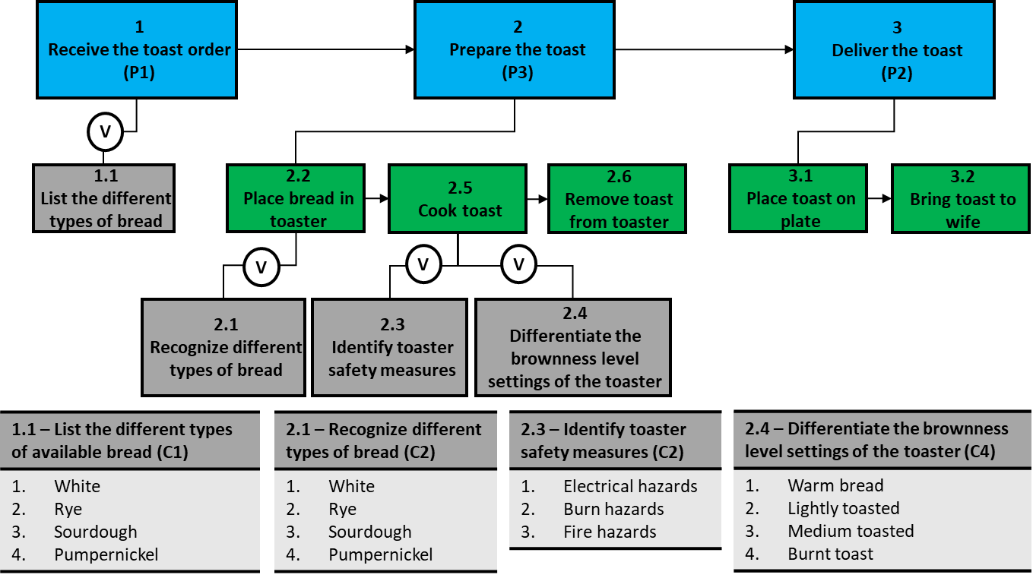

**Task Statements:**

1. Receive the toast order (Train)
2. Prepare the toast (Train)
3. Deliver the toast (No Train)

**Exercise:**

Rewrite the following Learning Objectives based on feedback from reviewers.

Ensure that each TLO and ELO meets the following checklist:

* Proper verbs are selected, and the proper tense is used
* The correct Learning Domain/Level is identified
* The conditions are clearly stated.
* The standards are observable, measurable, and complete

|  |  |
| --- | --- |
| 1.0 Terminal Learning Objective (TLO) | |
| Action: | Provide toast to a customer. |
| Conditions: | In a classroom environment, a customer order, selection of bread, toaster, and toaster user manual. |
| Standards: | Provide toast to a customer that is made to order using the correct bread choice and correct brownness level, in the proper sequence, without error. |
| Learning Domain/Level: Psychomotor/Manipulation (P2) | |

**Reviewer Comment:** Learning Domain/Level is not in line with the action verb “*Provide”*.Additionally, the subordinate learning objectives indicate the lesson should have a higher Learning Domain/Level.

|  |  |
| --- | --- |
| 1.1 Enabling Learning Objective (ELO) | |
| Action: | Identify different types of available bread to make toast. |
| Conditions: | In a classroom environment, given a selection of bread. |
| Standards: | Identify different types of available bread to make toast by knowing and visually recognizing the different types of available bread with a 70% accuracy. |
| Learning Domain/Level: Cognitive/Understand (C2) | |

**Reviewer Comment:** Standard statement is not in compliance. Incorrect tense for the verb. It is non-measurable as written Additionally, the 70% accuracy measurement indicates testing policy as opposed to a measure of performance.

|  |  |
| --- | --- |
| 1.2 Enabling Learning Objective (ELO) | |
| Action: | Choose the appropriate setup requirements of a toaster |
| Conditions: | In a classroom environment, given a customer order, toaster, and toaster user manual. |
| Standards: | Choose the appropriate setup requirements of a toaster by identifying two examples of safety hazards and differentiating all four brownness level settings to the appropriate toast brownness requirements. |
| Learning Domain/Level: Cognitive/Apply (C3) | |

**Reviewer Comment:** Standard statement is not in compliance. The use of verb(s) within the standards of measurement indicates either a higher-level Learning Domain/Level or the incorrect selection of verb(s).

|  |  |
| --- | --- |
| 1.3 Enabling Learning Objective (ELO) | |
| Action: | Prepare toast for a customer. |
| Conditions: | In a classroom environment, given a customer order, selection of bread, toaster, and toaster user manual. |
| Standards: | Prepare toast for a customer while adhering to all safety requirements, in the proper sequence, without error, within 10 minutes. |
| Learning Domain/Level: Psychomotor/Precision (P3) | |

**Reviewer Comment:** ELO is technically in compliance. As a subordinate Learning Objective, the Learning Domain/Level is higher than the Terminal Learning Objective. Either the ELO must be re-written or the TLO must be adjusted.

**Organizational Approved Verbs List:**

|  |  |  |
| --- | --- | --- |
| **Levels** | **Description** | **Verbs (not all inclusive)** |
| **C6- Create** | Create a new product or point of view | Assemble, construct, create, design, develop, formulate, write |
| **C5- Evaluate** | Justify a stand or decision | Appraise, argue, defend, judge, select, support, value, evaluate |
| **C4- Analyze** | Draw connections among ideas | Compare, contrast, differentiate, distinguish, examine, experiment, test |
| **C3- Apply** | Use information in new situations | Choose, demonstrate, illustrate, prepare, interpret, operate, schedule, sketch, solve, write |
| **C2- Understand** | Explain ideas or concepts | Classify, describe, discuss, explain, identify, locate, recognize, report, select |
| **C1- Remember** | Recall facts and basic concepts | Define, duplicate, list, memorize, recall, repeat, state |
| **A5- Internalize** | Adopt belief system and philosophy | Act, display, influence, solve, practice |
| **A4- Organize** | Reconcile internal conflicts, develop value system | Build, develop, formulate, defend, modify, relate, prioritize, reconcile, contrast, arrange, compare |
| **A3- Value** | Attach values and express personal opinions | Argue, challenge, debate, refute, confront, justify, persuade, criticize |
| **A2- Respond** | React and participate actively | React, respond, interpret, clarify, contribute, present, cite, write, perform |
| **A1- Receive** | Open willingness to listen | Ask, listen, focus, attend, take part, discuss, acknowledge, hear, retain, follow |
| **P5- Naturalization** | Automated mastery of activity | Design, specify, manage, invent |
| **P4- Articulation** | Adapt expertise to solve non-standard objective | Construct, solve, combine, coordinate, integrate, adapt, develop, formulate, modify |
| **P3- Precision** | Execute skill independently | Demonstrate, complete, prepare, show, perfect, calibrate, control, provide |
| **P2- Manipulation** | Reproduce instruction from memory | Re-create, build, perform, execute, deliver, implement |
| **P1- Imitation** | Observe and replication action | Copy, receive, follow, replicate, repeat, adhere |